**P5 - Identify the information systems used in a specified organisation**

**Recommended Information Systems for an IT Firm**A variety of information systems are required in order to run effectively. There are four categories of information system, as shown below. They are generally optimised to suit the user.

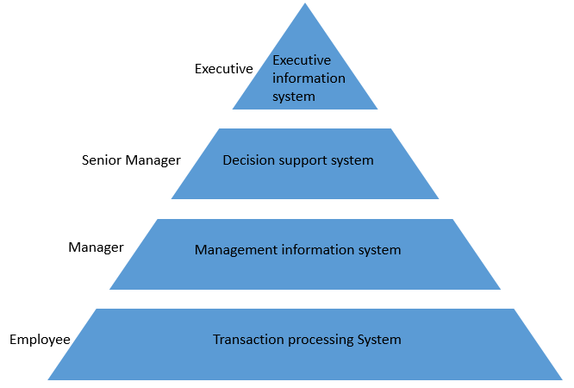

**Executive Information Systems**Executive Information systems are used at the highest level of an organisation to make strategic decisions. This type of information systems helps CEO’s and senior managers analyse how the company is functioning and identify how it can be improved. Data from external and internal sources is used such as sales information and information from stakeholders. The system takes all this data and summarises it or presents it in different formats that will allow executives to make strategic decisions on how the company will improve their profit etc. The systems are often made up of bespoke software which is created to suit the organisation’s need for developing executive information.This type of information system was chosen because it is effective at helping people in higher position within the IT firm to make good decisions on how they can improve their company. The information produce by this information system allows them to make important decision which could make the company more profitable and could improve how the company functions as a whole.

**Decision Support Systems**Decision Support Systems are knowledge based systems that senior managers can use to summarize information about the company. These type of Information Systems output information that is useful for deciding what to do in the future and how their decisions might affect the company in the future. Information is typically stored in databases with a variety of analytical tools to help process information in different ways.

**Logistics Systems**Logistics Information Systems take data and convert it into a good information that can be used to make difficult decisions in the firm. It can also review the development of the company using data from other information systems and present future scenarios that allow the firm to develop. A logistics information system was chosen for the firm because it makes decision making easier for senior manager/managers and can present new opportunities to the firm.

**Financial Systems**Financial Information Systems help a company manage their expenditure and costs. There are two main purposes in a financial system: to monitor financial costs and to help with investment returns. A financial system is able to identify any patterns or trends in the expenditure of the firm so can be used to analyse how money is spent and make sure the firm spends money effectively. As well as monitoring spending, the system can assess whether a particular investment is of high or low risk and whether it is work investing in by looking at the return the company gets. This information system was chosen as it is vital for managing the money within the firm. The system can identify any problems etc. and make sure that the firm doesn’t lose money and is not negatively affected by investments.

**Management Information Systems**A Management Information System is another form of decision support system. This type of information system is used by managers and senior managers to provide information about its business operations and manage the efficient running of the company. Management Information Systems have their complexity hidden from the user by having predefined input and output formats. The system itself can be used to support repetitive questions and track, analyse and help support key decisions that managers have to make. Management Information Systems require data to be accurate, sustainable and timely, and require their users to be able to use the system confidently.

**Marketing Systems**Marketing systems monitor the sales performance of the firm and can identify positive and negative trends/patterns. This system can be used to improve sales performance and identify competing companies, and show the affects they have on the business. Where sales performance is concerned, a marketing information system can identify whether the company has increasing or decreasing sales and why they are doing so. This allows the firm to gain more customers by adapting their business to suit the trend. Similarly, the system can identify any competing companies, show whether they are providing the same services and report the effects of this on the company. This can allow the firm to make important changes so they stay ahead of competitors and get more customers.This information system was chosen because it allows the firm to improve their appearance to potential clients/customers so that they increase their sales and profit. Using this system will allow the firm to expand their business and analyse and plan how they will proceed in the future.

**Human Resources Systems**Human Resource (HR) departments have to carry out analysis over vast areas of the company and often require an information system to make the process simpler. An HR information system assists with staffing and professional development. The number and quality of staff working in the firm is highly important as having the right staff allows the company to progress. The HR system can identify whether the staff have the right or wrong skills for the job and allow the department to assess if they will be hired etc. It can also analyse whether any staff need training, what the skills and experience of each person are and help aid professional development. This allows it to find candidates for any job vacancies within the firm.This system was chosen as managing human resources in any business is highly important. If the wrong people were hired in the firm it could prove catastrophic and the company might fail. By using a human resources information system the firm will be able to manage their staff easily and can help employees develop their profession skills etc. so that they can help the firm succeed.

**Customer Relationship Management Systems**Customer Relationship Management Systems are used to analyse customers’ interactions with the company by combining information from the sales and marketing information systems. This information can then be used by the firm to improve their relationship with their customers and ensure that they do not switch to competing companies, hence also improving sales. Besides improving sales, the system can be used to identify users’ needs and concerns allowing the firm to enhance their relationship with the customer base.This information system has been chosen as it allows the firm to address their customers’ needs by identifying the products and services they buy from the company and form a relationship with them. This information allows the company to mold their firm to the users’ needs and gain an advantage over their competitors.

**Transaction Processing Systems**Transaction Processing Systems work at an operational level in a firm. They are data processing systems that are uncomplicated and can be used by anyone in a company. These systems provide the key information that supports operational decisions within a company and they can track low-level activities and transactions and use them to produce information.

**Payroll Systems**Payroll systems are used to manage how much money the employees of the company will get and the filing of employment taxes. The system uses data, such as how many hours worked, rate of pay, taxes, bonuses, to calculate how much each employee is paid and produce paychecks; and pay taxes. This system makes it easier for workers, managers and the financial department to pay the employees of the firm. It also reduces the amount of time spent calculating a person’s wage and reduces human error.This systems was chosen because it manages the payment of employees within the company and is much faster and easier than a human manually working out each person’s wages.